

Department of Computer Science Course Code: CNS 303
Course Title: Cloud Computing Fundamentals

Spring 2026

Lab 08

Objective:
Micro services Deployment with Docker and Front-End Integration

Student Information

Student Name
Student ID
Date
Assessment
Marks Obtained
Remarks
Signature

Objective

To deploy a fully decoupled web application using Docker Compose. The lab environment consists of a Frontend container, a Backend API container, and a MySQL Database container communicating over an internal Docker network.

Architecture Diagram

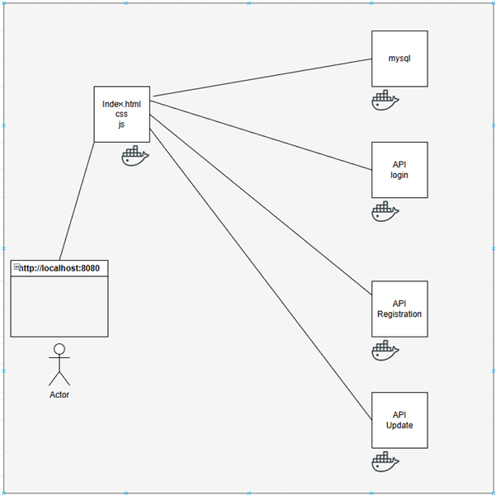

Project Directory Structure
Set up the following folders and files on your host machine:
lab-docker-php/
docker-compose.yml frontend/
index.php backend/
api.php mysql/
init.sql

File Implementation

Step 3.1: mysql/init.sql

CREATE TABLE IF NOT EXISTS system_status ( id INT AUTO_INCREMENT PRIMARY KEY,
status_message VARCHAR(255) NOT NULL
);
INSERT INTO system_status (status_message) VALUES ('Database Connection Successful');

Step 3.2: backend/api.php

<?php
header('Content-Type: application/json');
$dsn = 'mysql:host=db;dbname=lab_db'; try {
$pdo = new PDO($dsn, 'admin', 'secret');
$res = $pdo->query('SELECT status_message FROM system_status')->fetch(); echo json_encode(['status' => 'Success', 'db_msg' =>
$res['status_message']]);
} catch (Exception $e) {
echo json_encode(['status' => 'Error', 'msg' => $e->getMessage()]);
}

Step 3.3: frontend/index.php

<h1>Frontend Service</h1>
<?php
$resp = file_get_contents('http://backend-api/api.php');
$data = json_decode($resp, true);
echo '<p>Backend says: ' . $data['db_msg'] . '</p>';
?>

Docker Compose (docker-compose.yml)

version: '3.8' services:
db:
image: mysql:8.0 environment:
MYSQL_DATABASE: lab_db MYSQL_USER: admin MYSQL_PASSWORD: secret MYSQL_ROOT_PASSWORD: root
volumes:
- ./mysql/init.sql:/docker-entrypoint-initdb.d/init.sql

backend-api:
image: php:8.2-apache volumes:
- ./backend:/var/www/html command: >
sh -c 'docker-php-ext-install pdo pdo_mysql && apache2-foreground' depends_on:
- db

frontend:
image: php:8.2-apache ports:
- '8080:80'
volumes:
- ./frontend:/var/www/html depends_on:
- backend-api

Apply Docker Compose command to compose the yaml.

These commands manage the entire lifecycle of your application stack.

- docker compose up: Creates and starts all containers defined in your configuration.
  - docker compose up -d: Runs containers in "detached" mode (background).
  - docker compose up --build: Rebuilds images before starting containers.
- docker compose down: Stops and removes containers, networks, and images created by up.
  - docker compose down -v: Also removes named volumes.
- docker compose start / stop: Starts or stops existing containers without creating or removing them.
- docker compose pause / unpause: Pauses and resumes running containers.

TASK # 1:

  - Open terminal in the project root directory.
  - Execute "docker-compose up -d" to build and start services.
  - Check status with "docker-compose ps".
  - Open http://localhost:8080 in your browser.
  - To stop the lab, use "docker-compose down".

TASK # 2:

- Implement CRUD operation APIs with above code.

